Problem :-

Problem detected!

[mysql] Port 3306 in use by "Unable to open process"!

[mysql] MySQL WILL NOT start without the configured ports free!

[mysql] You need to uninstall/disable/reconfigure the blocking application

[mysql] or reconfigure MySQL and the Control Panel to listen on a different port

Solution:-

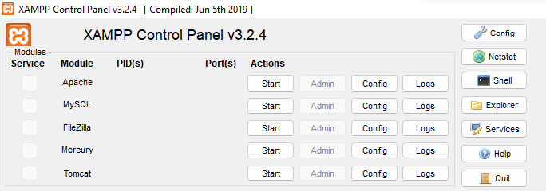

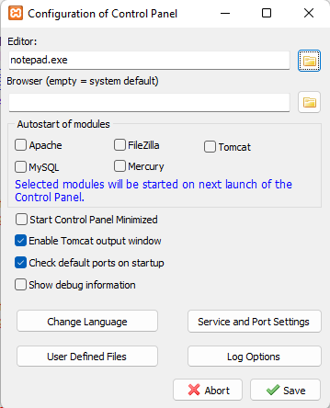

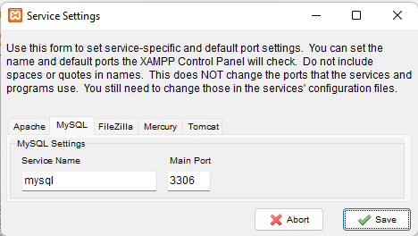

Change the port and save it

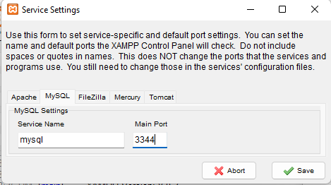





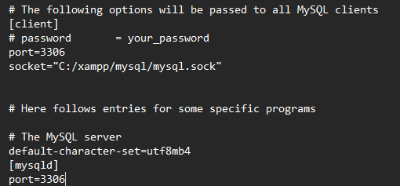

Change both the port to 3344 and save it and close it.

Now find the location:-

C:\xampp\phpMyAdmin\config.inc.php or config.inc

Open it



Add after 127.0.0.1:3344 and save it